Environment
The New World of the Americas presented all kinds of new animals, plants and landscapes to European travellers, explorers and migrants. New settlers also had to contend with the impact and consequences of different climates. New England, where the Mayflower passengers settled, presented particular challenges; not fully appreciating the climate, the first harsh winter in the Plymouth colony resulted in a large number of deaths. Around half of the colony died in this first winter. With little time or knowledge to develop a sustainable food source for themselves, the colonists relied on local, indigenous people to help them survive their first winter. They were not the first, nor the last, group of settlers who relied on indigenous local knowledge to help them establish and sustain a foothold in the North American continent.
There are many accounts of the environment of New England that help us imagine both the visual and emotional impression that this overwhelming expanse of landscape made on early travellers and explorers. Thomas Harriot’s, John Smith’s, and even Bradford’s accounts, as well as many others, make clear that the initial bounty of the New World’s natural resources would serve transatlantic trading arrangements. Maps drawn and published by John Smith and Samuel de Champlain in the early seventeenth century, provided travellers and settlers with navigable routes in and around the New England coast.
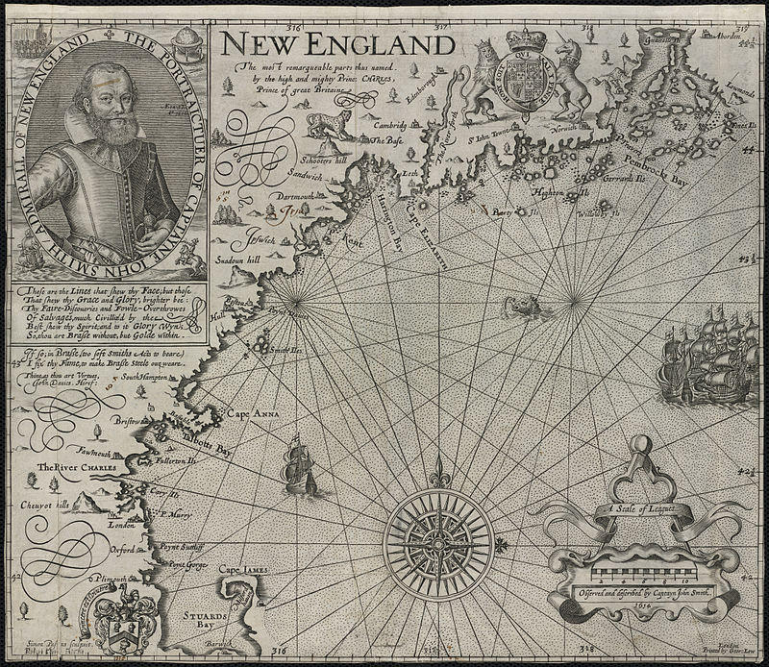

The new scientific knowledge that the New World offered also found its way into colonial society and their correspondence. John Josselyn’s New England Rarities, discovered in Birds, Beasts, Fishes, Serpents, and Plants of that Country (London, 1671) is one of the first natural histories of Anglo-North America. It’s one of the first publications to attend to the natural world of New England from a quasi-scientific point of view, rather than from a purely mercantile point of view.
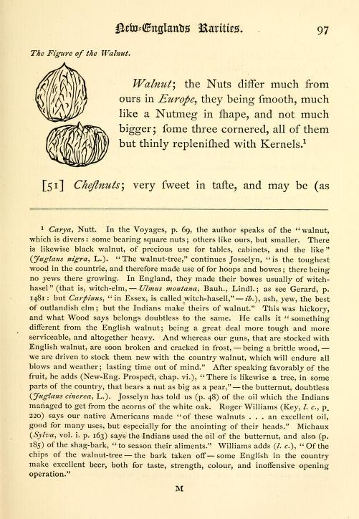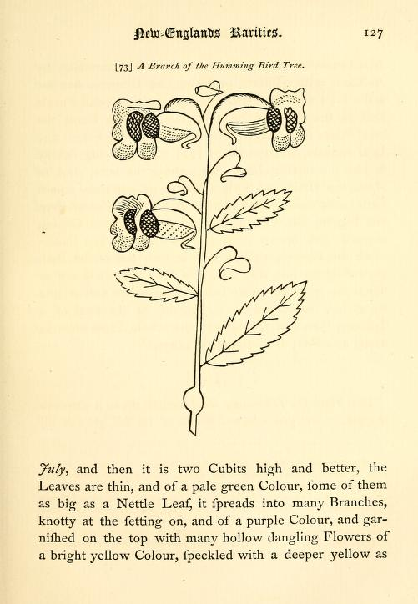

(see, Josselyn, New England’s Rarities, 1671)

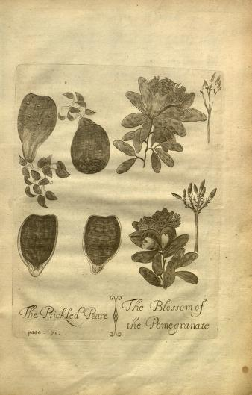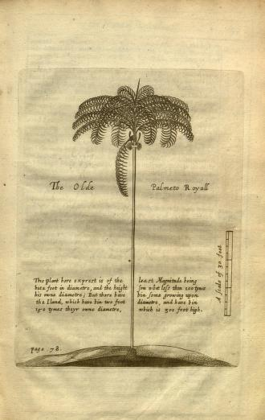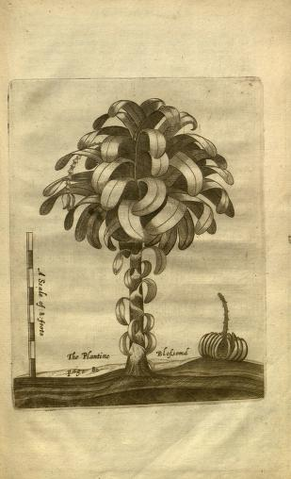
From Richard Ligon, A True & Exact History of the Island of Barbados (1657, 1673)

Primary sources:
Thomas Harriot, A Briefe and True Report of the New Found Land of Virginia (London, 1588)
Samuel de Champlain, Voyages of Samuel de Champlain, 1604-1618
Anon. Mourt’s Relation (London,1622)
John Smith, A General History of Virginia, New England and the Summer Isles (London, 1624)
Richard Ligon, A True & Exact History of the Island of Barbados (1657, 1673). Ed. Karen O. Kupperman. (Hackett Publishers, 2011)
John Josselyn, New England's Rarities, discovered in Birds, Beasts, Fishes, Serpents, and Plants of that Country (London, 1671)
John Josselyn, An Account of Two Voyages to New England (London 1674)
William Bradford, Of Plymouth Plantation (ms. circa 1640)

Further reading:

Rochelle Johnson and Daniel Patterson, “Writing About Nature in Early America: From Discovery to 1850,” in Patrick D. Murphy, ed., Literature of Nature: An International Sourcebook (Chicago: Fitzroy Dearborn, 1998)

Paul Lindholdt, “Early American Natural Histories,” in Patrick D. Murphy, ed. Literature of Nature: An International Sourcebook (Chicago: Fitzroy Dearborn, 1998)

Henry Lowood, “The New World and the European Catalog of Nature,” in Karen Ordahl Kupperman, ed., America in European Consciousness, 1493–1750. (Chapel Hill: University of North Carolina Press, 1995)

Susan Scott Parrish, American Curiosity: Cultures of Natural History in the Colonial British Atlantic World (Chapel Hill: University of North Carolina Press, 2006)

