Belonging, community and family
Establishing a settled community of saints was an important motivation for the Separatist Puritans when they journeyed to New England in 1620. Initially, it was intended that they would set up a community in Virginia but, by veering too far north, they planted the colony outside of the original charter’s reach. This challenged the colonists to consider questions of authority, law and order; it challenged them to determine a group identity that existed outside of the pre-established legal parameters which the charter offered.
Aware of the problems this posed, and aware that many of the colonists on board didn’t share the same regard for law and order, Bradford recalls ‘discontented and mutinous speeches’ of the ‘strangers’ on board, a compact or covenant between them was designed to maintain order and shape the future settlement and success of the colony. This was called the Mayflower Compact and it bound the signatories to sharing in the civil and legal acts and ordinances of the colonial endeavour.
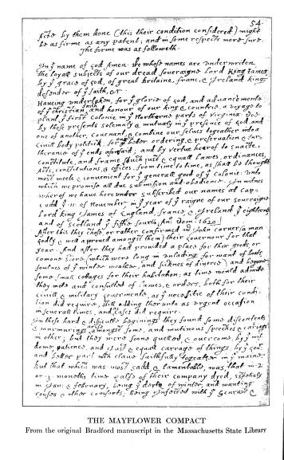
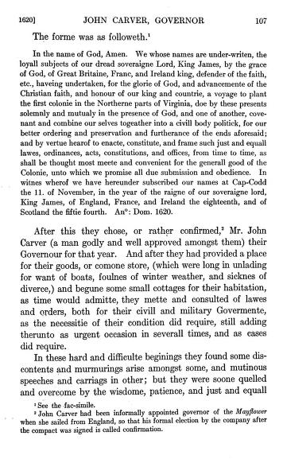

The Puritans of Plymouth colony were influential, and the underlying principles of Christianity and the Bible were the bedrock of their day-to-day lives, as well as their civil and legal frameworks. The deaths of rebellious individuals are put down to God’s providence, as were the diseases that swept across the Native American tribes and ‘cleared’ a space for the colonists. Bradford declares marriage a civil matter with reference to the Old Testament, the Book of Ruth, and follows experiences in Leiden. The larger point is to consider that civil laws and social expectations in the Puritan colony had roots in Christian beliefs and the Bible. In Plymouth colony, as in the later, larger Puritan colony in Massachusetts Bay, religious views shaped their decision-making processes, in matters small and large.
The Wampanoag across the New England area, and beyond, had their own customs and traditions, their own creation stories and social systems, all of which determined their own decision-making processes. Roger Williams’s Key into the Language of America (London, 1643), what we might call a cultural phrasebook today, describes and navigates the language and culture of the Narragansett, a near neighbour of the Plymouth colony. Particular customs related to hospitality, to relations, marriage, kinship ties, modes of travel, the climate, husbandry, hunting, religion, government, justice, monetary exchange, trade, and warfare, are all embedded in Williams’s narrative. While it is written through eyes of a colonial settler, and may not be completely accurate, it does give some insight into the practical details of Native American life and the social structures and expectations that underpinned it. Native Americans were not the ‘tabula rasa’, or blank slate, that colonial commentators, missionaries in particular, would have liked them to be.
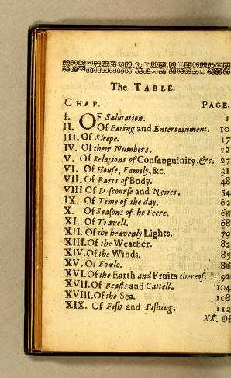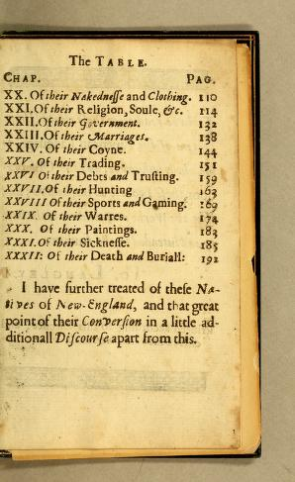
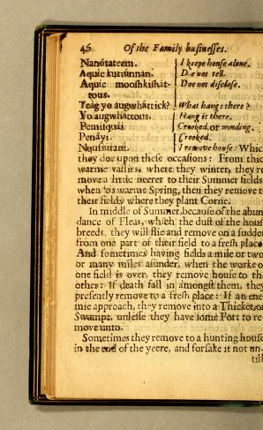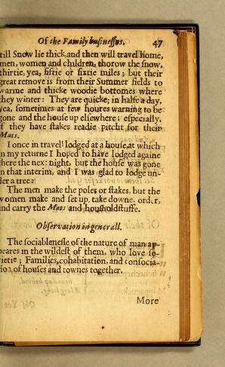

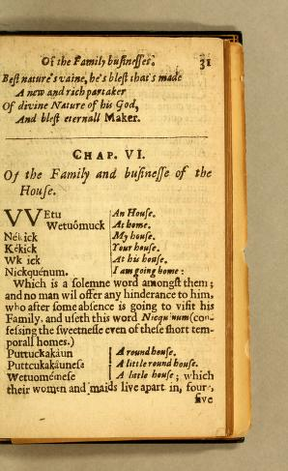

Edmund S. Morgan, The Puritan Family (HarperCollins , 1966)
Howard S. Russell, Indian New England Before the Mayflower (University Press of New England, 1980)

